H.T No
Regulations:
A17

Sreenidhi Institute of Science and Technology
(An Autonomous Institution)
Code No: 6C446 Date: 09-July-2021 (AN)
B.Tech II-Year II- Semester Pending External Examination, July - 2021 (Supplementary)
Electronic Circuits (EEE)

Time: 3 Hours Max.Marks:75

Note: a) No additional answer sheets will be provided.
b) All sub-parts of a question must be answered at one place only, otherwise it will not be valued.
c) Missing data can be assumed suitably.

ANSWER ANY 5 OUT OF 8 QUESTIONS. EACH QUESTION CARRIES 15 MARKS.

Bloom's Cognitive Levels of Learning (BCLL)

Remember | L1 | Apply | L3 | Evaluate | L5
Understand | L2 | Analyze | L4 | Create | L6

 |  |  | BCLL | CO(s) | Marks
1. | a) | Draw the circuit of CE amplifier with un bypassed emitter resister and derive expression for R_{i}, R_{o}, A_{V} and A_{i} using approximate h-parameter model. | L3 | CO1 | [8M]
 | b) | Why does the gain of the single stage RC coupled amplifier roll off on either side of the frequency band? | L2 | CO1 | [7M]
2. | a) | The block diagram shown in below fig is the topology of a feedback amplifier mention the  i) Name of the feedback amplifier.  ii) Name of the basic amplifier.  iii) Name of the input signal, X_{i}  iv) Name of the feedback signal X_{f}  v) Sampling and mixing techniques implemented.  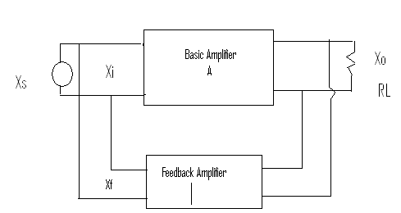  Fig | L3 | CO2 | [8M]
 | b) | Explain the operation of crystal oscillators with necessary diagrams. Also discuss its advantages and disadvantages. | L2 | CO2 | [7M]
3. | a) | Explain how a Low pass RC Circuit act as Integrator. | L2 | CO3 | [8M]
 | b) | What is clamping circuit? With a neat circuit diagram and waveforms explain the working of +ve and –ve clamper assuming square wave input. | L1 | CO3 | [7M]
4. | a) | Design the typical CE characteristics circuit with V_{cc}=15V, R_{c}=1.5KΩ,Calculate the transistor power dissipation (i) at cutoff (ii) at saturation | L5 | CO4 | [8M]
 | b) | Define the turn on time of transistor? Explain how transistor act as a switch. | L1 | CO4 | [7M]
5. | a) | Explain the working of a bistable multivibrator circuit with help of neat  waveforms. | L2 | CO5 | [8M]
 | b) | Explain the operation of Schmitt trigger with neat sketches and derive the expression to UTP and LTP. | L2 | CO5 | [7M]
6. | a) | Draw the diagram of a transformer coupled class A power amplifier and explain the need for impedance matching? | L1 | CO6 | [8M]
 | b) | What is cross over distortion in class-B Push Pull amplifier? How is it eliminated? | L2 | CO6 | [7M]
7. | a) | Determine the frequency of oscillations in a Wein bridge oscillator. | L3 | CO1 | [8M]
 | b) | A symmetrical square wave of amplitude ±5 V, and frequency 2KHz is impressed on RC low pass circuit. If R=5KΩ, C=0.1µF, Calculate and plot the steady state output with respect to time. | L4 | CO2 | [7M]
8. | a) | Draw the circuit diagram of a collector coupled astable multivibrator and explain the operation with the help of base and collector wave forms. | L3 | CO4 | [8M]
 | b) | Explain the working of complementary symmetry amplifier with a neat circuit diagram | L2 | CO5 | [7M]

-- 00 -- 00 –

